FOR IMMEDIATE RELEASE
WORLD PREMIERE: TIM KLIPHUIS TRIO:
THE STIRLING QUEEN 4 NOV, 7.30PM
The Queen’s Hall commissions new piece for 40th anniversary based on the early life of Queen Margaret
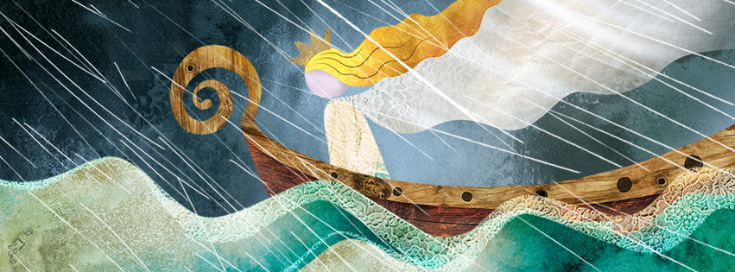The Stirling Queen artwork designed by Helen Wyllie, wylliecat design.
Imagine being married off to a Scottish king when you are 14 years old. Sailing across the sea from Denmark to be the wife of someone you hardly know. Your father gives away Shetland and the Orkney Islands as your wedding present.
This is the inspiration for a brand new piece of work ‘The Stirling Queen’ commissioned by The Queen’s Hall to celebrate its fortieth anniversary as a music venue in 2019. Written by Tim Kliphuis, with Scottish and Nordic roots and influences of gypsy, baroque and minimal music, the composition tells the story of Queen Margaret’s youth, her marriage to James III and her early death at Stirling Castle.
Tim Kliphuis has written and will perform this work for an ensemble comprised of his trio - Nigel Clark (guitar) and Roy Percy (bass), - Perthshire fiddle ace, Patsy Reid, Ireland’s Young Musician of the Year, Clare Friel and students at The City Edinburgh Music School at Broughton High School. This one-off programme shows how music is a universal language, crossing the boundaries between styles and countries.
Tim Kliphuis says, “I have blended the sounds of the gypsy jazz trio with the Scottish and Irish fiddling traditions to show in different colours the adventures that the Danish Princess had. We’ll be telling the story in concert!”
Support comes from Fiddlers on the Ramp, five lifelong friends who all attended The City of Edinburgh Music School and have honed a unique sound developed through years of busking and gigging around the streets of Edinburgh.
The world premiere of this new piece will take place at The Queen’s Hall on Monday 4 November from 7.30pm. Tickets are on sale now, £9-£17 via this link: https://www.thequeenshall.net/whats-on/tim-kliphuis-trio or by calling +44 (0)131 668 2019.
Presented by The Queen's Hall and supported by Sam & Renate Breadon
For interviews, hi-res images and press tickets please contact:
Emma Mortimore, Marketing Manager: 0131 622 7381 | emmam@queenshalledinburgh.org
NOTES FOR EDITORS
Tim Kliphuis is an award-winning Dutch violinist who has created a brand new style that embraces classical, gypsy jazz and folk. Hailed as a ‘current-day improvising Paganini’, his inclusive approach to music has united audiences and is influencing a new generation of string players.

Tim and his Trio (Nigel Clark, guitar and Roy Percy, double bass) are firm favourites on the Scottish scene and have shared the stage with Les Paul, Richard Galliano, Frankie Gavin and Martin Hayes, as well as the Netherlands and Tallinn Chamber Orchestras, The Hague and Cape Town Philharmonic and Sinfonietta Amsterdam.

Kliphuis is an in-demand educator at festivals, competitions and conservatoires. He wrote the best-selling book “Gypsy Jazz Violin” and teaches improvisation at the Amsterdam Conservatoire, at his own Academy for Improvising Strings, and the gypsy jazz summer school Grappelli-Django Camp.
https://www.timkliphuis.com

Patsy Reid (violin and viola) is a former member of Braebach, currently touring with Sam Sweeney (Bellowhead). She has a string of collaborations to her name with Dougie Maclean, Indian drum legend Zakir Hussain, and fiddlers Martin Hayes, Duncan Chisholm and Catriona MacDonald.
http://www.patsyreid.com/

Clare Friel (violin) is one the Friel Sisters and winner of Irish Young Folk Musician of the Year 2018. She has toured already with the Chieftains, Lúnasa, Sharon Shannon and Máirtín O’Connor in Europe, America and Asia.

Fiddlers on the Ramp are Malcolm Goodare (cello), Callum Morton-Teng (fiddle/mandolin), Aly Morton-Teng (cello/banjo), Mark Reid (guitar) and Rob Taylor (fiddle).
https://rabneil.wixsite.com/fiddlersontheramp

The Queen’s Hall (Scottish Charity No SC012294) was officially opened by HM Queen Elizabeth II on 6 July 1979 and is celebrating forty years as Edinburgh’s foremost mid-sized live music venue throughout 2019 with an extraordinary range of world-class artists from all musical fields: classical, jazz, folk and roots, rock and pop and Americana including a series of QH@40 gigs with guest curators, supported by Creative Scotland. The perfectly-proportioned, intimate auditorium, flawless acoustics and adaptability make it a unique and valuable resource in Edinburgh’s cultural life. The Queen’s Hall has provided facilities for the International, Fringe, Jazz, Film, Fiddle and Science Festivals and for many local amateur and professional groups, as well as being a key venue for music, comedy and spoken-word acts touring (inter)nationally. Annual audiences total around 90,000 and the venue works with up to 3,000 artists and support staff as well as partnering on year-round music learning and community engagement projects with the City of Edinburgh Council, The City of Edinburgh Music School, Drake Music Scotland and other schools and education providers. www.thequeenshall.net

The City of Edinburgh Music School is unique within Europe in its offering of a complete specialist music programme to primary and secondary students, ensuring their musical development from an early age within a caring and sensitive framework. The intensive training – involving regular practice, various ensembles and individual expert tuition from the most talented and dedicated teachers in the land - paves the way for their students to secure positions in some of the most prestigious colleges, universities, ensembles, orchestras and media organisations in the world. The school has a commitment to all styles of music. Building on their exceptional reputation for classical teaching they also offer expertise in the fields of rock, jazz and traditional Scottish music.
https://www.edinburghmusicschool.co.uk/

